**ID: PP-1**

**Date Written –** 4/1/2020

**Date Revised –** 4/05/2020

**Author: Malia Rohrig, Ean Petersen, Erika Tiemeier, Jonathon Platt**

**Protocol Description – (Bioreactor Roller Micropump)**

**3D Printing**

This protocol is for the fabrication of a micropump which can be used to supply fluid to a small bioreactor. The device was designed to deliver up to 300 ml/min of fluid and is composed of a small stepper-motor and some 3D printed parts. The STL files are located *C:\\Micropump\STL Files* and need to be imported into the Slic3r program located *C:\\Slic3r*. In the slicer program, you will need to make sure the part is oriented in an upright position so that the largest flat section rests on the build plate. In the slicer program, navigate to **File → Load Config** and load the configuration file with the preset template located *C:\\Slic3r\Configurations\Ceramic Template*. When the part(s) are situated in the center of the platform and the configuration file is loaded, navigate to the Export G-Code button located on the right-hand side of the program. Export the G-Code file to a known directory. Navigate to the GpxUi application located at *C:\\Slic3r\Ceramic Printer\GpxUi*. Load the G-Code file into the GPX -- Gcode to X3g converter and click **Translate!** button and save the .x3g file to a known directory. Load the file onto a 3D printer and select **Print from SD** from the menu and choose your filename to start the print.

**Micropump Assembly**

Micropump consists of: stepper motor, two 3D printed ceramic pieces, two bearings, and various hardware (screws, washers, nuts, etc) [see **Figure 1**]. The 3D printed housing located *C:\\Micropump\STL Files\Housing* will be screwed down using two long screws and two bolts to the stepper motor on the side with the driveshaft [see **Figure 2**]. Make sure the piece is securely fastened and is centered on the motor. The 3D printed bearing hub located *C:\\Micropump\STL Files\Bearing Hub* needs to be assembled using two bearings, two small bolts, two washers, and two small nuts. This piece then slides onto the stepper motor drive shaft until it is securely in place. Your desired tubing can then be fed into the 3D printed housing and by rotating the 3D printed hub manually fed through the pump [see **Figure 3**]. Once the micropump is completely assembled, it is attached to the breadboard and arduino [see **Figure 4**].

**Tools and Equipment**

|  |  |  |  |  |
| --- | --- | --- | --- | --- |
| **ID** | **Tool** | **Name / # if applicable** | **Location** | **Purpose** |
| PT1 | Arduino | N/A | Desktop Computer | Check UI and calibration of circuit |
| PT2 | Breadboard Circuit | N/A | - | Reusable construction base for prototyping circuit |
| PT3 | Copper wires | N/A | - | Attach circuit components for functionality |
| PT4 | Ceramic  3D Printer | 3DCeram C3600 Ultimate | Benam Laboratory | 3D Printing |
| PT5 | Solidworks | N/A | Desktop Computer | Produce CAD for printhead |
| PT6 | Slic3r | N/A | Design Lab | Convert STL file to G-code |
| PT7 | GpxUI | N/A | Design Lab Computer | Convert G-code into X3G file for FDM printing |
| PT8 | Arduino UNO | N/A | Design Lab | Used to run stepper motor using written code |
| PT9 | Power Supply | 12V-2A-24W | - | power the stepper motor |

**Materials**

|  |  |  |
| --- | --- | --- |
| **ID** | **Material** | **Purpose** |
| PM1 | Silica-filled Ceramic Resin (FLCEWH01) | Used to 3D print thermoresistant printhead |
| PM2 | Stepper motor | Used drive the pump |
| PM3 | 1/8” OD 1/16” ID Tygon tubing | Isolation and movement of the fluid |
| PM4 | Hardware (washers, nuts) | Connecting 3D parts to driver motor |
| PM5 | 3D printed ceramic guard | Holds tubing in position |
| PM6 | Assorted Electronics (capacitors, resistors, etc) | Added to the circuit for functionality |

**Computer Files**

|  |  |  |  |
| --- | --- | --- | --- |
| **ID** | **FileName / Link** | **Purpose** | **Location** |
| CF1 | Circuit Diagram | Show layout of circuit design and functionality | *C:\\Micropump\Circuit* |
| CF2 | CAD Bearing Hub | Structural and material change for increased performance | *C:\\Micropump\STL Files* |
| CF3 | Arduino code | Running device | *C:\\Micropump\Arduino\Code* |

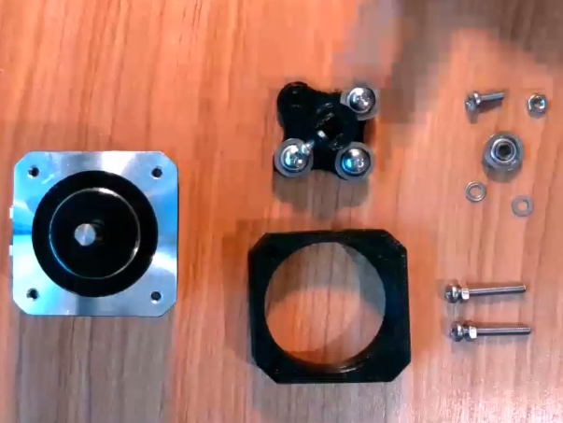

**Figure 1.** Unassembled pump with parts and hardware visible. Stepper motor (far left), 3D printed housing (bottom middle), 3D printed bearing hub with three bearings attached (middle top) and misc. hardware (right).

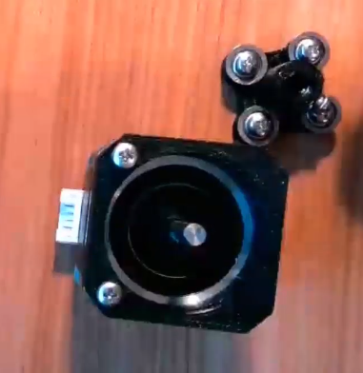

**Figure 2.**  Fully assembled 3D printed bearing hub (top right) with the 3D printed housing attached to stepper motor (bottom middle).

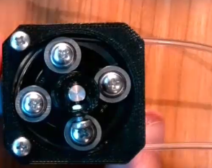

**Figure 3.** Completed assembled pump with tubing inserted. Two of the pictured bearings will be removed in final design.

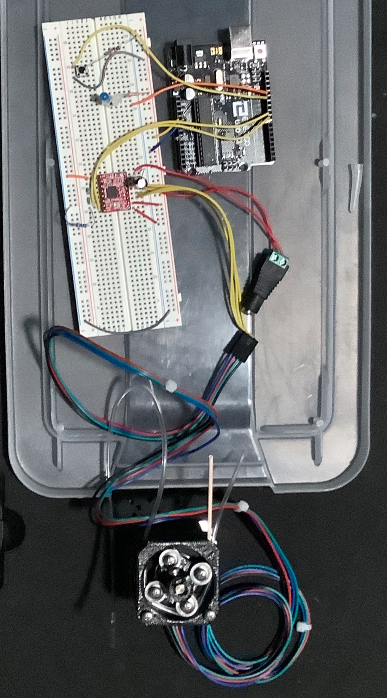

**Figure 4.** Shows original functional micropump correctly wired to breadboard and Arduino.